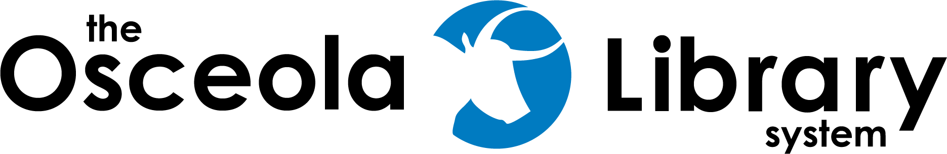

Memorial Book Request

In Memory Of | Given By

Name of Donor (if different)

Donor Address

Phone | Email

Inscription (maximum 20 words)

Donation Amount (minimum $25) Cash, Credit Card or Check accepted  Make Check payable to Osceola County Board of County Commissioners | $

Book Details – Subject Areas, Authors or Titles
[ ] Fiction | [ ] NonFiction |  | [ ] Children’s | [ ] Teens
[ ] Regular Type |  | [ ] Large Print

Titles/subjects/authors selected will fit with the Library’s Collection Development Policy.

